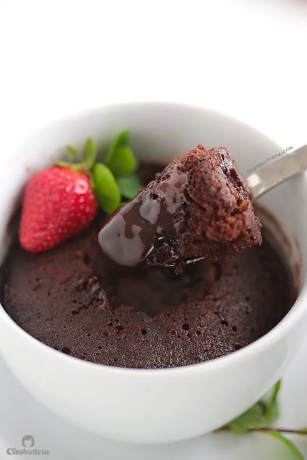
Molten Chocolate Mug Cake

Ingredients
- ¼ cup flour
- ¼ cup granulated sugar
- 2 tablespoons unsweetened cocoa powder (I used Hershey's)
- ½ teaspoon baking powder
- Pinch of salt
- 3 tablepoons (1½oz) melted butter
- 3 tablespoons whole milk, at room temperature
- 1 smallish egg, at room temperature
- ½ teaspoon vanilla extract
- 1 oz (28 grams) semisweet chocolate, lightly broken up
- 1 tablespoon water
Instructions
- In a 2-cup capacity microwave-safe mug* (see note), whisk together with a fork, the flour, sugar, cocoa powder, baking powder and salt until well combined.
- Add in the melted butter, milk, egg and vanilla. Whisk well to combine, making sure to mix in the flour mixture in the bottom.
- Place the chocolate pieces in the center of the mug. Do not push down; it will sink as it bakes.
- Drizzle the tablespoon of water right on top of the batter.
- Cook in microwave on full power for 1 minute and 20 seconds to 2 minutes (1 minute and 25 seconds is my magic number), or until the cake rises to the top, the edges look set but the center looks ever-so-slighly wet and shiny but not raw, and sticks slightly to the finger when touched. Do NOT overbake to ensure that saucy, molten-y interior. If the center still looks raw then give it another 5 to 10 seconds. The cake will fall after it comes out of the microwave.
- Let it cool for about 5 minutes so you don't burn your tongue, but the waiting also help thicken the sauce in the bottom.
Notes
* A short mug with a wide mouth works best for this recipe. If not available, a small bowl could be used instead. To know if your mug/or bowl is the right size, pour 2 cups of water in it and this should fill it to the top.

